|  |  |
| --- | --- |
| South High School | RedOX and Electrochemistry |

|  |
| --- |
| Regents Chemistry  Dr. Lombardo  NAME __________________________________________ |

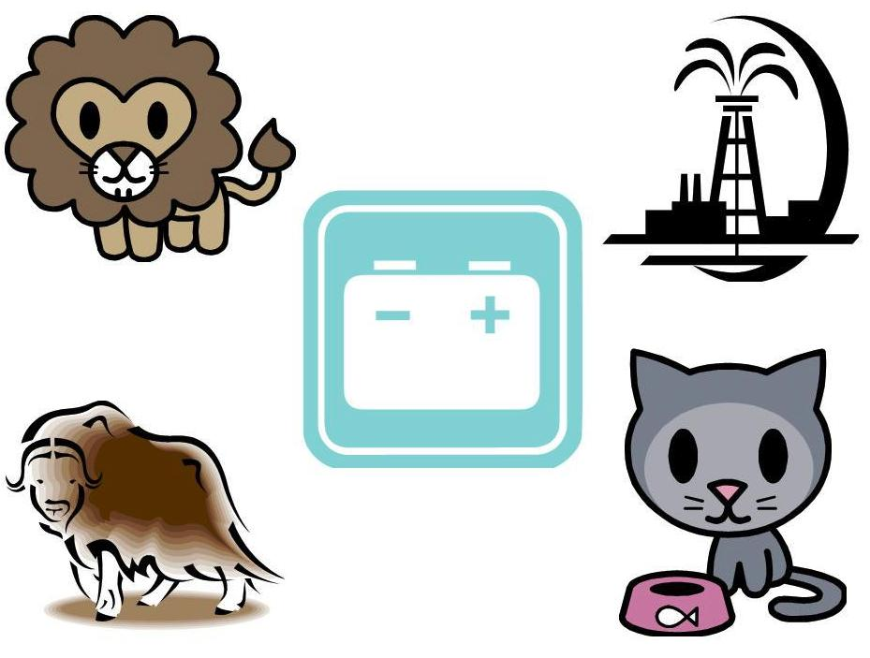

**Content Objectives**

* What will students know and be able to do by the end of this instructional unit?
* Determine a missing reactant or product in a balanced equation
* Write and balance half-reactions for oxidation and reduction of free elements and there monatomic ions
* Identify and label the parts of a voltaic cell, (cathode, anode, and salt bridge, and direction of electron flow, given the reaction)
* Use an activity series to determine whether a redox reaction is spontaneous
* Identify and label the parts of a electrolytic cell, (cathode, anode, and direction of electron flow, given the reaction)
* Compare and contrast voltaic and electrolytic cell

**Key Subject Competencies**

* Assign oxidation states to atoms and ions based on the number of electrons gained or lost during formation of bonds.
* Create the rules for assigning oxidation states.
* Assign oxidation states to atoms and ions based on the number of electrons gained or lost during formation of bonds.
* Create the rules for assigning oxidation states.
* Calculate the oxidation states of the individual species in compounds and polyatomic ions.
* Recognize that in a redox reaction the number of electrons lost is equal to the number of electrons gained.
* Assign oxidation states to atoms and ions based on the number of electrons gained or lost during formation of bonds.
* Identify a redox reaction based on the fact that at least 2 species in the reaction change their oxidation states
* Demonstrate that the number of electrons lost by one or more species in a chemical reaction is equal to the number of electrons gained by one or more species in a chemical reaction.
* Identify an oxidation-reduction reaction.
* Determine what is being transferred from one element to another in an oxidation-reduction reaction.
* Determine which element is oxidized in an oxidation-reduction reaction.
* Explain what is meant by oxidation.
* Determine what element is reduced in an oxidation-reduction reaction.
* Explain what is meant by reduction.
* Recognize reducing and oxidizing agents in a reaction
* Recognize reduced and oxidized species in a reaction
* Decide what the charges are in each element of a reaction
* Balance half reactions
* Balance full reactions
* Compare voltaic cell to electrolytic cell
* Identify the anode and the cathode of an electrochemical cell.
* Determine the reactions at the anode and cathode.
* Determine if a given reaction is spontaneous.
* Give the function of the salt bridge.
* Distinguish between flow of ions and flow of electrons.
* Compare voltaic and electrolytic cells
* Compare spontaneous and non-spontaneous reactions
* Define electrolysis
* Explain the use of electrolysis to obtain active metals and in electroplating

**Vocabulary**

* Anode
* Cathode
* Electrochemical cell
* Electrode
* Electrolysis
* Electrolytic cell
* Half-reaction
* Oxidation
* Oxidation number
* Redox
* Reduction
* Salt bridge
* Voltaic cell

Review of Terms

Oxidation-Reduction (RedOx) reaction: _____________________________________________

(Actually 2 different reactions occurring at the same time.)

Oxidation:

Reduction:

**Example:**

Na + Cl → NaCl

What element was oxidized? ____________

What element was reduced? ____________



C:\Users\Salvatore Lombardo\AppData\Local\Microsoft\Windows\Temporary Internet Files\Content.IE5\IRKD6H6V\MC900290379[1].wmf

**Determining Oxidation States**

What is the oxidation state of each of the following species?

Cl

Mg

Na

F

Sr

O

**Rules for Determining Oxidation Numbers**

1. ____________________________ have an oxidation number of __________
   1. Na, S8, H2
2. All ________________ in group _____ have a ______________________in compounds.
   1. Na, K, Li
3. All ________________ in group _____ have a ______________________in compounds.
   1. Mg, Ca, Ba
4. ________________ has a ______________________
   1. Unless it is in a ______________ like ______________

1. ________________ has a ______________________
2. ________________ have a _____________________
3. For any _____________________________, the sum of the oxidation numbers of the

atoms in the compound ______________.

* 1. H2SO4

1. For a ___________________________, the sum of the oxidation numbers must equal the

__________________________________of the ion.

* 1. Ex: SO4 **2-**

Find the oxidation states in the formulas below.

|  |  |
| --- | --- |
| CuF2 | PBr3 |
| HNO3 | C2O4-2 |
| SO4-2 | CO3-2 |
| C12H22O11 | H2O |

**OXIDATION**

Can be defined as:

____________________________________________________________

____________________________________________________________

____________________________________________________________

* The loss of electrons
  + Na(s) 🡪 Na+ + e-
  + The sodium ion has been ***________________________***to the sodium cation.
* Gain of oxygen
  + ________________________________________ reactions are classic examples
  + C(s) + O2(g) 🡪 CO2(g)  (burning of coal)
  + 2Fe(s) + 3O2(g) 🡪 2Fe2O3(s) (rusting of iron)
* Loss of hydrogen
  + Oxidation can sometimes be best seen as the _____________________________
  + CH3OH(l) 🡪 CH2O(l) + H2(g)
  + Methyl alcohol has been oxidized into formaldehyde

**Which one of the following elements were oxidized?**

|  |  |
| --- | --- |
| Clorine | Flourine |
| Magnesium | Strontium |
| Sodium | Oxygen |

**REDUCTION**

Can be defined as:

____________________________________________________________

____________________________________________________________

____________________________________________________________

* Gain of electrons
  + The process of silver electroplating
  + Ag+ + e- 🡪 Ag
  + Silver cation has gained an electron and has been ________________ to silver metal.
* Loss of oxygen
  + Reduction can also be seen as the loss of oxygen in going from reactant to product.
  + Fe2O2 (s) + 3 CO (g) 🡪 2 Fe(s) + 3 CO2(g)
  + Iron ore is ________________ to iron metal in a blast furnace with carbon monoxide
* Gain of hydrogen
  + A reduction can also be described as the gain of hydrogen atoms going from reactant to product.
    - CO(g) + 2 H2(g) 🡪 CH3OH(l)
  + Carbon monoxide has been ____________________ to methyl alcohol

**One’s loss is another’s gain**

* Neither oxidation nor reduction can take place without the other.
  + When electrons are lost something has to gain them.

When trying to remember which is which think of:

LEO the lion goes GER OIL RIG

|  |  |  |  |  |
| --- | --- | --- | --- | --- |
| **Elements** |  |  |  |  |
| Oxidation State |  |  |  |  |
| Number of Atoms |  |  |  |  |
| Total Charge |  |  |  |  |

,

Find The following in each equation:

Oxidation States, what is reduced, what is oxidized

|  |
| --- |
| Mg + HCl  MgCl2 + H2 |
| Fe + V2O3  Fe2O3 + VO |
| KMnO4 + KNO2 + H2SO4  MnSO4 + H2O + KNO3 + K2SO4 |
| K2Cr2O7 + SnCl2 + HCl  CrCl3 + SnCl4 + KCl + H2O |
| KMnO4 + NaCl + H2SO4  Cl2 + K2SO4 + MnSO4 + H2O + Na2SO4 |
| K2Cr2O7 + H2O + S  SO2 + KOH + Cr2O3 |
| KClO3 + C12H22O11  KCl + H2O + CO2 |
| H2C2O4 + K2MnO4  CO2 + K2O + Mn2O3 + H2O |
| Mn(NO3) 2 + NaBiO3 + HNO3  HMnO4 + Bi(NO3) 3 + NaNO3 + H2O |
| H2C2O4 + KMnO4  CO2 + K2O + Mn2O3 + H2O |

1. When a substance is oxidized, it

1. loses protons
2. gains protons
3. acts as an oxidizing agent
4. acts as a reducing agent

2. Given the redox reaction: Fe2+(*aq*) + Zn(*s*) → Zn2+(*aq*) + Fe(*s*)  
 Which species acts as a reducing agent?

1. Fe(*s*)
2. Fe2+(*aq*)
3. Zn(*s*)
4. Zn2+(*aq*)

3. Which balanced equation represents a redox reaction?

1. PCl5 → PCl3 + Cl2
2. KOH + HCl → KCl + H2O
3. LiBr → Li+ + Br−
4. Ca2+ + SO42− → CaSO4

4. Which change in oxidation number indicates oxidation?

1. -1 to +2
2. -1 to -2
3. +2 to -3
4. +3 to +2

5. In the reaction: 2Mg + O2 → 2MgO, the magnesium is the

1. oxidizing agent and is reduced
2. oxidizing agent and is oxidized
3. reducing agent and is reduced
4. reducing agent and is oxidized

6. Given the redox reaction: Cr3+ + Al → Cr + Al3+

As the reaction takes place, there is a transfer of

1. electrons from Al to Cr3+
2. electrons from Cr3+ to Al
3. protons from Al to Cr3+
4. protons from Cr3+ to Al

7. Given the reaction: Cu(*s*) + 4HNO3(*aq*) → Cu(NO3)2(*aq*) + 2NO3(*g*) + 2H2O(*l* )  
 As the reaction occurs, what happens to copper?

1. It undergoes reduction and its oxidation number decreases.
2. It undergoes reduction and its oxidation number increases.
3. It undergoes oxidation and its oxidation number decreases.
4. It undergoes oxidation and its oxidation numbeincreases.

8. Oxygen will have a positive oxidation number when combined with

1. fluorine
2. chlorine
3. bromine
4. iodine

9. The unbalanced equation below represents the decomposition of potassium chlorate.

KClO3(s) → KCl(s) + O2(g)

Determine the oxidation number of chlorine in the reactant. Answer: ________________

10. Which element is more reactive than strontium?

1. potassium
2. calcium
3. iron
4. copper

11. What is the oxidation state of nitrogen in the compound NH4Br?

1. –1
2. +2
3. –3
4. +4

12. Given the reaction: Zn(*s*) + Cu2+(*aq*) → Zn2+(*aq*) + Cu(*s*)  
 Which particles must be transferred from one reactant to the other reactant?

1. ions
2. neutrons
3. protons
4. electrons

13. Which ionic equation is balanced?

1. Fe3+ + Al → Fe2+ + Al3+
2. Fe3+ + 3Al → Fe2+ + 3Al3+
3. 3Fe3+ + Al → 3Fe2+ + Al3+
4. 3Fe3+ + Al → Fe2+ + 3Al3+

14. Which balanced equation represents an oxidation-reduction reaction?

1. BaCl2 + Na2SO4 → BaSO4 + 2NaCl
2. C + H2O → CO + H2
3. CaCO3 → CaO + CO2
4. Mg(OH)2 + 2HNO3 → Mg(NO3)2 + 2H2O

15. In the reaction: 2H2S + 3O2 → 2SO2 + 2H2O, the oxidizing agent is

1. oxygen
2. water
3. sulfur dioxide
4. hydrogen sulfide

16. What happens to reducing agents in chemical reactions?

1. Reducing agents gain protons.
2. Reducing agents gain electrons.
3. Reducing agents are oxidized.
4. Reducing agents are reduced.

17. Given the reaction:   http://castlelearning.com/review/Courses/chem/chem060218-q0.gif?v=20021119122928   
 Which species undergoes oxidation?

1. Mg(*s*)
2. H+(*aq*)
3. Cl-(*aq*)
4. H2(*g*)

**Half Reactions**

* An oxidation-reduction, (redox), reaction involves the transfer of electrons.
  + Ex. Sodium transfers electrons to Chlorine
  + The oxidation numbers of the atoms will change…. one goes up (oxidation) and one goes down (reduction)
* Reduction
  + ___________________________________________________

___________________________________________________

* + Reduction half reaction
    - _______________________________________________
    - _______________________________________________
* Oxidation
  + ___________________________________________________

___________________________________________________

* + Oxidation half reaction
    - _______________________________________________
    - _______________________________________________

Half Reaction

* Show either the oxidation or reduction portion of a redox reaction ________________ the electrons gained or lost.  
    
  Steps for writing half-reactions

1. Assign an oxidation number to each element.
2. Write a partial half-reaction to show the change in oxidation state:

Oxidation:

Reduction:

1. Show the number of electrons needed to explain how the oxidation number changed.

Oxidation:

Reduction:

1. Last, but not least, achieve conservation of charge:

**Practice Problems**

4. Base your answer to the following question on the information below.
   1. In a laboratory investigation, magnesium reacts with hydrochloric acid to produce hydrogen gas and magnesium chloride. This reaction is represented by the unbalanced equation below.

Mg(s) + HCl(aq)  H2(g) + MgCl2(aq)

Write a balanced half-reaction equation for the oxidation that occurs.

1. Base your answer to the following question on the unbalanced redox reaction below.

Cu(s) + AgNO3(aq)  Cu(NO3)2(aq) + Ag(s)

* 1. Write the reduction half-reaction.

1. Zinc metal reacts with hydrochloric acid to produce zinc chloride and hydrogen gas according to the reaction below:

Zn(s) + HCl(aq)  ZnCl2 + H2(g)

*a* Explain why this reaction is classified as an oxidation-reduction reaction.

*b* Which reactant is oxidized? Explain your answer.

c What is the oxidation number of zinc in zinc chloride?

**Table J**

* Table J tells us if a redox reaction can occur between an atom and an ion.
  + A more active metal will replace an ion ___________________ it on Table J.
  + A more active nonmetal will replace an ion ___________________ it on Table J.
  + Any metal ______________________ H is more active than H and will react with an acid to produce H2(g)
    - The higher up the table, the more readily the replacement will take place.
* A more active metal will replace a less active metal from its compound.
  + - Zinc replaces copper because zinc is more active than copper.
  + Cu + ZnSO4 → No Reaction
    - Copper cannot replace zinc

Oxidation is on top Reduction is on bottom

For each reaction below, identify the atom oxidized and the atom reduced, then balance the equation by the method of oxidation-reduction showing all electrons transfers.

1. Mg + HCl → MgCl2 + H2
2. Fe + V2O3 → Fe2O3 + VO
3. KMnO4 + KNO2 + H2SO4 → MnSO4 + H2O + KNO3 + K2SO4
4. K2Cr2O7 + SnCl2 + HCl → CrCl3 + SnCl4 + KCl + H2O
5. KMnO4 + NaCl + H2SO4 → Cl2 + K2SO4 + MnSO4 + H2O + Na2SO4

**Welcome to Electrochemical Cells**

An electrochemical cell can be either _____________________ or _______________________. In any electrochemical cell, oxidation occurs at the anode and reduction at the cathode

_____________________ occurs at the _____________________.

_____________________ occurs at the _____________________.

**A voltaic cell spontaneously converts chemical energy to electrical energy.**

Electrons flow from the ___________________ (- electrode) to the _______________________

(+ electrode) through the wire in a ____________________ cell.

The ________________________________ completes the circuit allows _________________ to flow from one ½ cell to the other ½ cell to maintain neutrality

1. Which statement is true about oxidation and reduction in an electrochemical cell?
   1. Both occur at the anode.
   2. Both occur at the cathode.
   3. Oxidation occurs at the anode and reduction occurs at the cathode.
   4. Oxidation occurs at the cathode and reduction occurs at the anode.
2. Which energy conversion occurs during the operation of a voltaic cell?
   1. Chemical energy is spontaneously converted to electrical energy.
   2. Chemical energy is converted to electrical energy only when an external power source is provided.
   3. Electrical energy is spontaneously converted to chemical energy.
   4. Electrical energy is converted to chemical energy only when an external power source is provided.
3. Given the overall reaction for the lead-acid battery:  
   http://castlelearning.com/review/Courses/chem/q1114.gif?v=20010112072600   
   Which element changes oxidation state when electric energy is produced?
   1. hydrogen
   2. oxygen
   3. sulfur
   4. lead
4. Base your answer to the question on the diagram of the voltaic cell.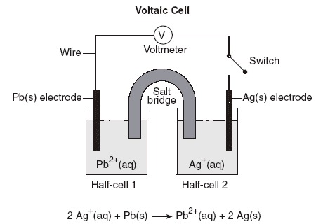B

B*ased on the given equation*, the balanced half-reaction that occurs in half-cell 1 is

* 1. Pb(*s*) → Pb2+(*aq*) + 2e−
  2. 2Ag(*s*) → 2Ag+(*aq*) + 2e−
  3. Pb2+(*aq*) + 2e− → Pb(*s*)
  4. 2Ag+(*aq*) + 2e− → Ag(*s*)

1. Given the balanced equation representing the reaction occurring in a voltaic cell:  
   Zn(s) + Pb2+(aq) → Zn2+(aq) + Pb(s)

In the completed external circuit, the electrons flow from

* 1. Pb(s) to Zn(s)
  2. Pb2+(aq) to Zn2+(aq)
  3. Zn(s) to Pb(s)
  4. Zn2+(aq) to Pb2+(aq)

1. Which conversion of energy always occurs in a voltaic cell?
   1. light energy to chemical energy
   2. electrical energy to chemical energy
   3. chemical energy to light energy
   4. chemical energy to electrical energy
2. Which statement best describes how a salt bridge maintains electrical neutrality in the half-cells of an voltaic cell?
   1. It prevents the migration of electrons.
   2. It permits the migration of ions.
   3. It permits the two solutions to mix completely.
   4. It prevents the reaction from occuring spontaneously.
3. Base your answer to this question on the information below   
   The diagram below represents an operating voltaic cell at 298 K and 1.0 atmosphere in a laboratory investigation. The reaction occurring in the cell is represented by the balanced ionic equation below.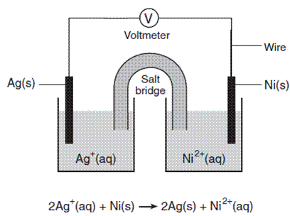

Identify the anode in this cell.

* 1. Ag(s)
  2. Ni(s)
  3. Ag+(aq)
  4. Ni2+(aq)

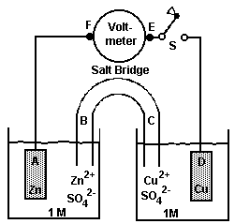

1. The diagram represents a voltaic cell. When the switch is closed, which group of letters correctly represents the direction of electron flow?
   1. *A* → *B* → *C* → *D*
   2. *A* → *F*→ *E* → *D*
   3. *D* → *C* → *B* → *A*
   4. *D* → *F* → *E* → *A*
2. A diagram of a chemical cell and an equation are shown below.

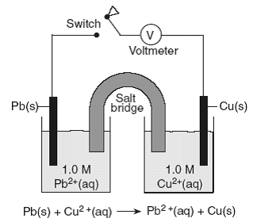

When the switch is closed, electrons will flow from

* 1. the Pb(*s*) to the Cu(*s*)
  2. the Cu(*s*) to the Pb(*s*)
  3. the Pb2+(*aq*) to the Pb(*s*)
  4. the Cu2+(*aq*) to the Cu(*s*)